Winter Outlook: Return of El Niño?

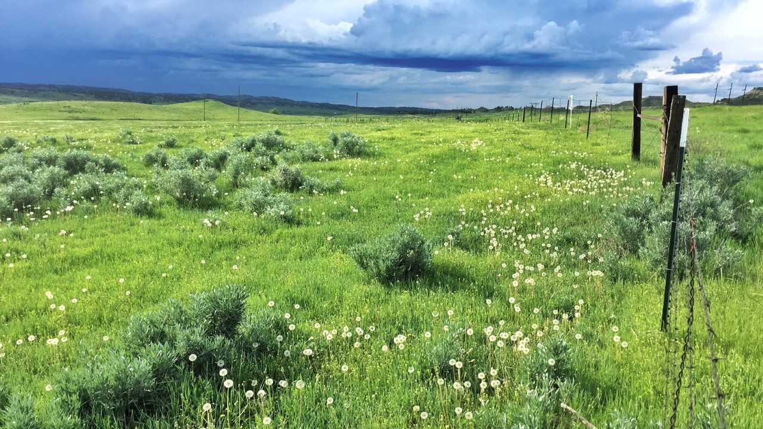

Photo: Kevin Hyde

## 

### El Niño Outlook

This past winter and spring the Pacific sea surface temperatures remained below average, maintaining La Niña conditions in the ocean and lower atmosphere. This resulted in a significant winter snowpack, wet conditions and much below normal spring temperatures. In late April the La Niña transitioned to ENSO neutral. During ENSO-neutral phases, ocean temperatures and atmospheric conditions are near the long-term average and there is often less predictability in the three month summer outlook (e.g., the seasonal outlook for temperature and precipitation in Eastern MT below).

#### Temperature

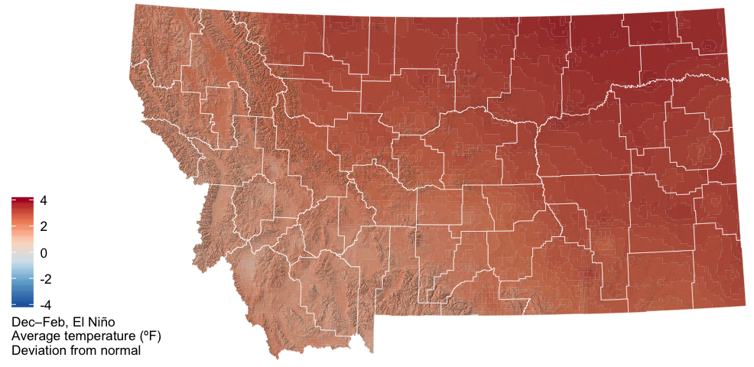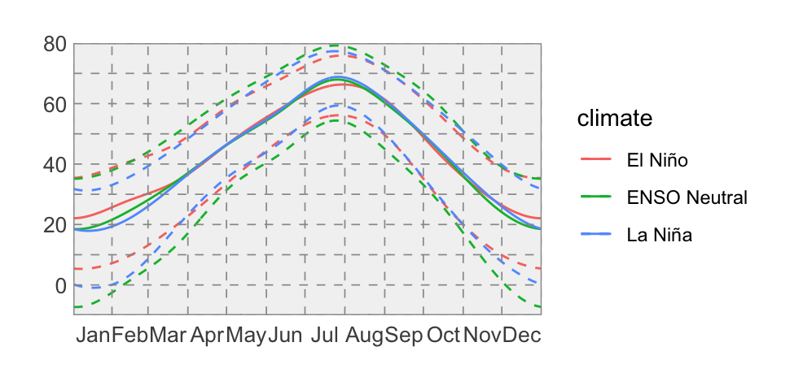

#### Precipitation

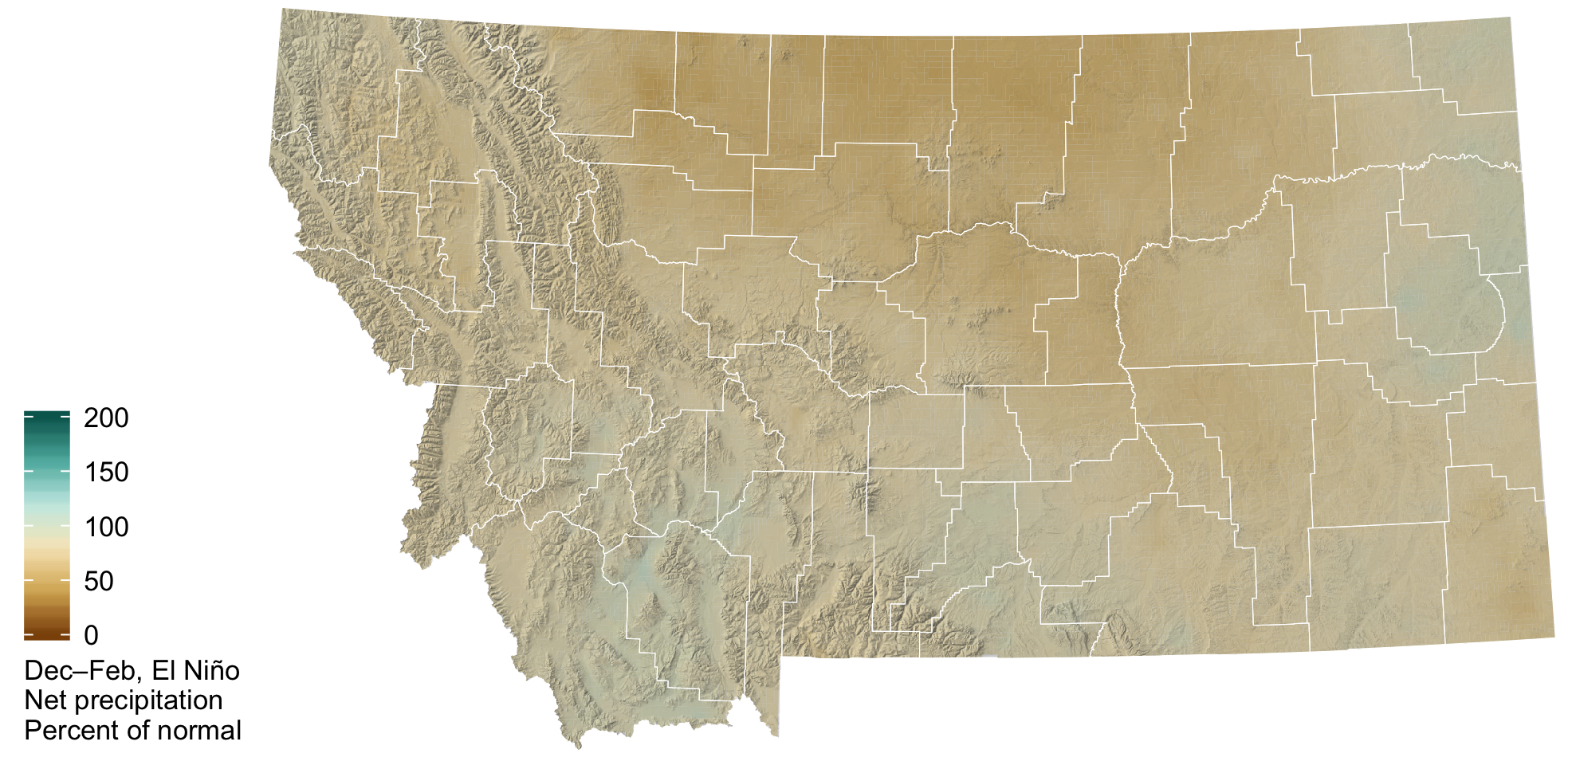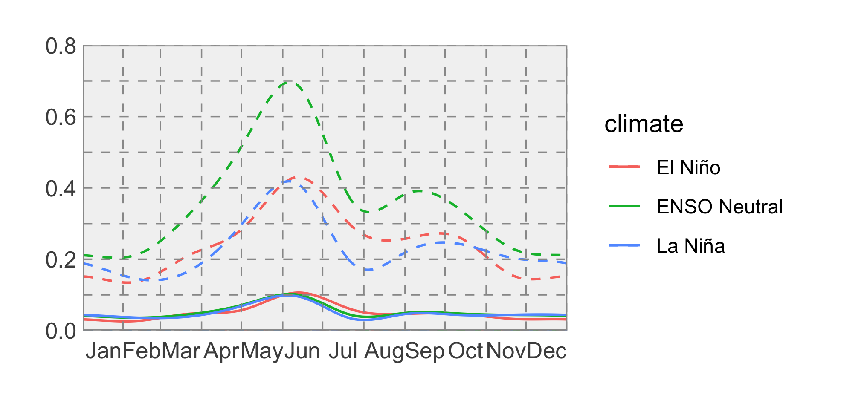

### Temperature

The summer outlook is for warmer than normal temperatures across western and central portions of the state. If the warmer temperatures occur as forecasted, they will contribute to increased evapotranspiration and the potential dry down of spring soil moisture reserves. The forecast is less certain in eastern portions of the state which means that there are equal chances of above, below, or normal summer temperatures.

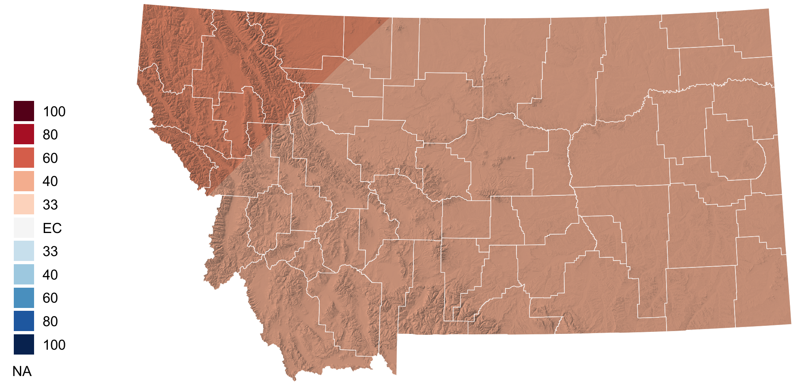

### Precipitation

The summer outlook for precipitation is drier than normal across northwestern, southwestern, and north-central portions of the state. There may be potential for the development of drought conditions as the summer progresses in these regions if we do indeed experience drier than normal conditions in conjunction with above normal temperatures (see above). The forecast is less certain in eastern portions of the state which means that there are equal chances of above, below, or normal summer precipitation.

